**Chapter 7 - Metabolism**

**All Lectures Uploaded on YouTube:**

[**https://tinyurl.com/fkm9-biology**](https://tinyurl.com/fkm9-biology)



## A chemical reaction is a process in which one or more substances, the reactants, are converted to one or more different substances, the products. Those chemical reactions which are taking place in living organisms are called biochemical reactions.

## **7.1 Metabolism and Its Types**

Metabolism means “to change”. It is the sum of all biochemical reactions occurring inside the cells of living organisms to maintain life. These reactions are essential for growth, repair, reproduction, movement, and energy production.

Metabolism is divided into two types, i.e. catabolism and anabolism.  
  
Catabolism:  
Catabolic reactions break complex molecules into simpler ones with release of energy.  
Examples:  
• Digestion of food  
• Cellular respiration where glucose breaks down into CO₂ and H₂O

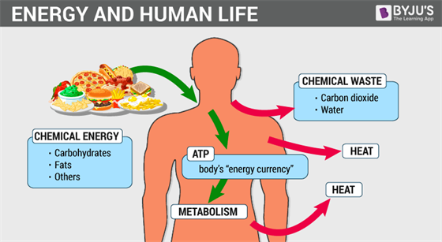

Anabolism:  
Anabolic reactions build complex molecules from simpler ones using energy.  
Examples:  
• Photosynthesis  
• Formation of glycogen from glucose

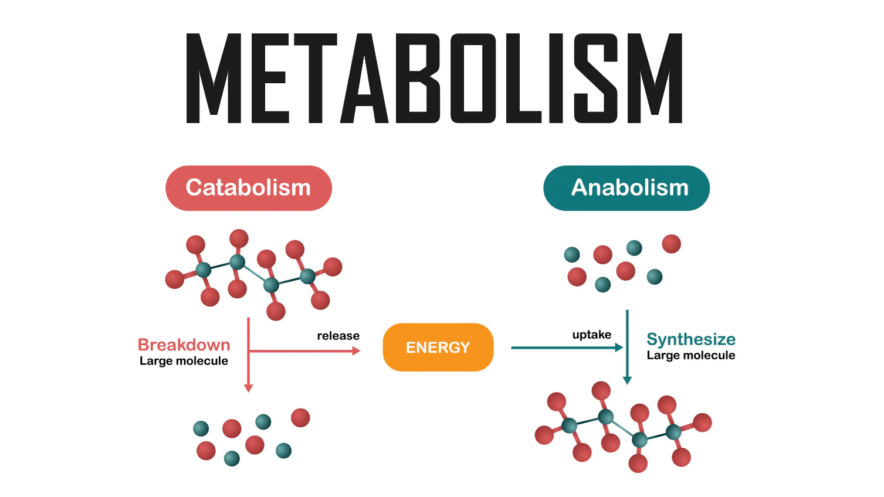  
  
Energy released in catabolism is used in anabolic reactions.

## **7.2 Enzymes and Their Characteristics**

“Enzymes are biologically active globular proteins made by living cells, which tremendously speed up the biochemical cell reactions.”

Enzymes work as biological catalysts, speeding up reactions by lowering activation energy without being used up, by binding to specific substrates at their active site like a key in a lock, positioning them perfectly to be converted into products. They facilitate this by stressing substrate bonds, providing the right chemical environment, and holding molecules in the optimal orientation, making life-sustaining reactions happen rapidly and efficiently under mild conditions.   
  
Types:  
• Intracellular enzymes act inside cells  
• Extracellular enzymes act outside cells

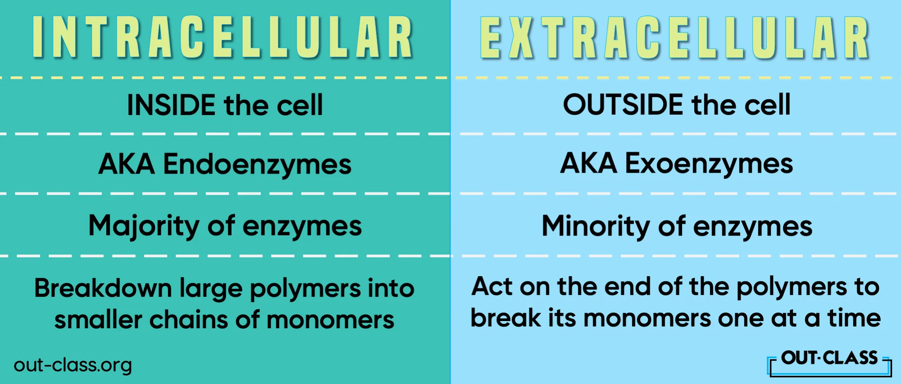  
  
The study of enzymes is called enzymology.

## **7.2.1 Characteristics of Enzymes**

1. Globular Proteins:  
Most enzymes are globular proteins with specific 3D shapes. Some RNA enzymes are ribozymes.  
  
2. Increase Rate of Reaction:  
Enzymes speed up reactions millions of times without initiating them.

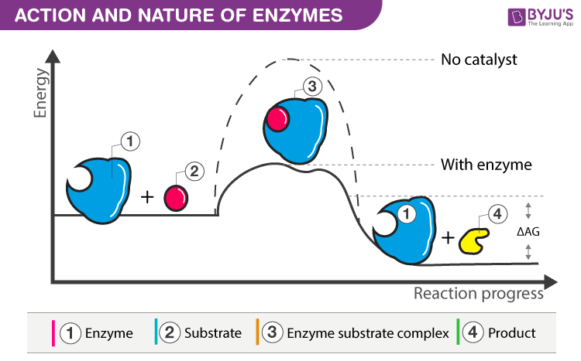  
  
3. Required in Small Quantity:  
Enzymes are reusable and remain unchanged.  
  
4. Specificity:  
Each enzyme works on a specific substrate.  
  
5. Cofactors:  
Many enzymes require cofactors.  
 • Activators: Zn²⁺, Fe²⁺, Cl⁻  
 • Prosthetic groups: FAD  
 • Coenzymes: NAD, NADP, Coenzyme A  
  
6. Regulation:  
Enzyme activity is regulated by activators and inhibitors.  
  
7. Metabolic Pathways:  
Enzymes act in sequences forming metabolic pathways.  
  
Energy of Activation:  
Minimum energy needed to start a reaction; enzymes lower it.

## **7.3 Mechanism of Enzyme Action**

Most enzymes are far larger protein molecules than the substrates they act on. The specific part on the globular surface of the enzyme where the substrate binds and actually takes part in reaction is called the active site.

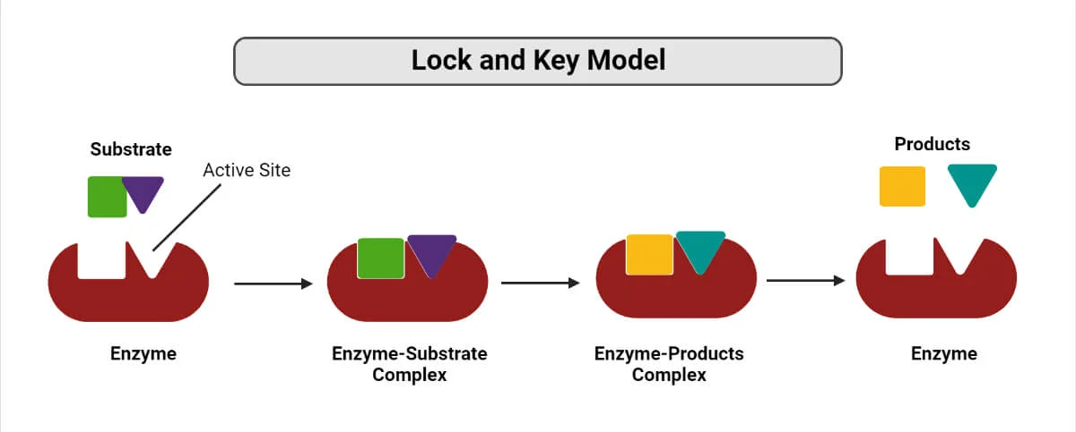

Steps:  
 1. Substrate binds to enzyme active site  
 2. Enzyme-Substrate complex forms  
 3. Product formation  
 4. Enzyme-Product complex forms  
 5. Product released  
 6. Enzyme reused

## **7.4 Factors Affecting Enzyme Activity**

**7.4.1. Temperature**

Each enzyme works best at a specific temperature called optimum temperature. For human enzymes, it is 36°C to 38°C. Moreover, different enzymes have differ a specific temperatures.

Temperature significantly affects enzyme activity: increasing it boosts activity by enhancing collisions up to an optimum temperature, where it peaks (around body temperature for humans); beyond this, high heat denatures the enzyme, breaking bonds, losing shape, and drastically reducing or stopping function, while freezing slows it down but usually doesn't destroy it.

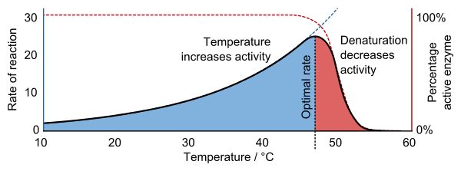

• Optimum temperature for human enzymes is 36–38°C  
• High temperature denatures enzymes  
• Low temperature slows reactions  
  
**7.4.2. pH**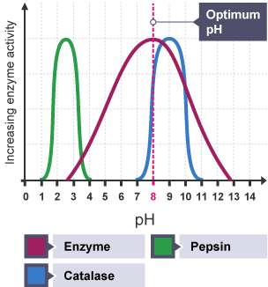

pH affects enzyme activity by altering the enzyme's 3D shape, particularly its active site; each enzyme has an optimal pH for peak function, but extreme deviations (too acidic or alkaline) disrupt bonds, causing denaturation and reduced or complete loss of activity, as seen in the bell-shaped curve of activity.

• Each enzyme has optimum pH  
• Pepsin works at pH 2  
• Trypsin works at pH 8

**7.4.3. Substrate Concentration**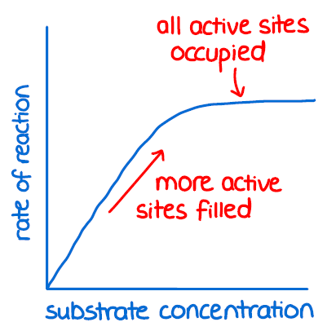

Increasing substrate concentration initially boosts enzyme activity proportionally, as more active sites get filled, but eventually, the rate plateaus when all enzyme active sites are saturated, meaning adding more substrate won't increase the reaction speed until more enzymes are available.

• Rate increases until saturation

## **7.5 Enzyme Inhibition**

Sometimes enzymes are not able to perform their role due to the presence and interference of some chemicals at the reaction site, this phenomenon is called enzyme inhibition. The chemical substance which reacts with enzymes in place of substrate but does not convert to products thus inhibiting the enzyme action is called inhibitor. Inhibitors may block or damage an active site temporarily or permanently.

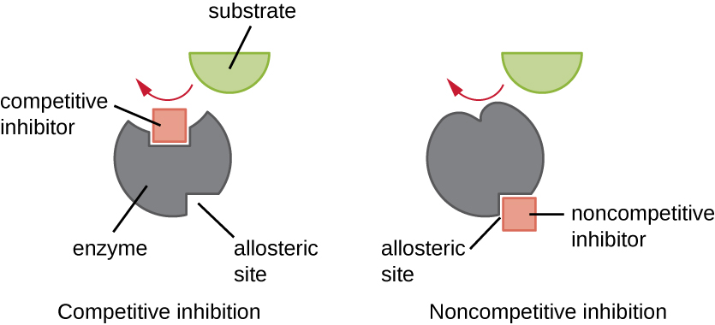

**7.5.1. Competitive Inhibition:**

• Inhibitor competes with substrate at active site

**7.5.2. Non-Competitive Inhibition:**

• Inhibitor binds at allosteric site and changes enzyme shape

## **7.6 Role of ATP – Energy Currency of Cell**

Life of the living organisms is possible only if constant processes of energy are available in its cells. All the life processes like movement, development, reproduction, thermoregulation, active transport, availability etc, depend on the energy.

**7.6.1. ATP - ADP Cycle**

ATP stores and releases energy.

ATP–ADP Cycle:  
ATP → ADP + Energy

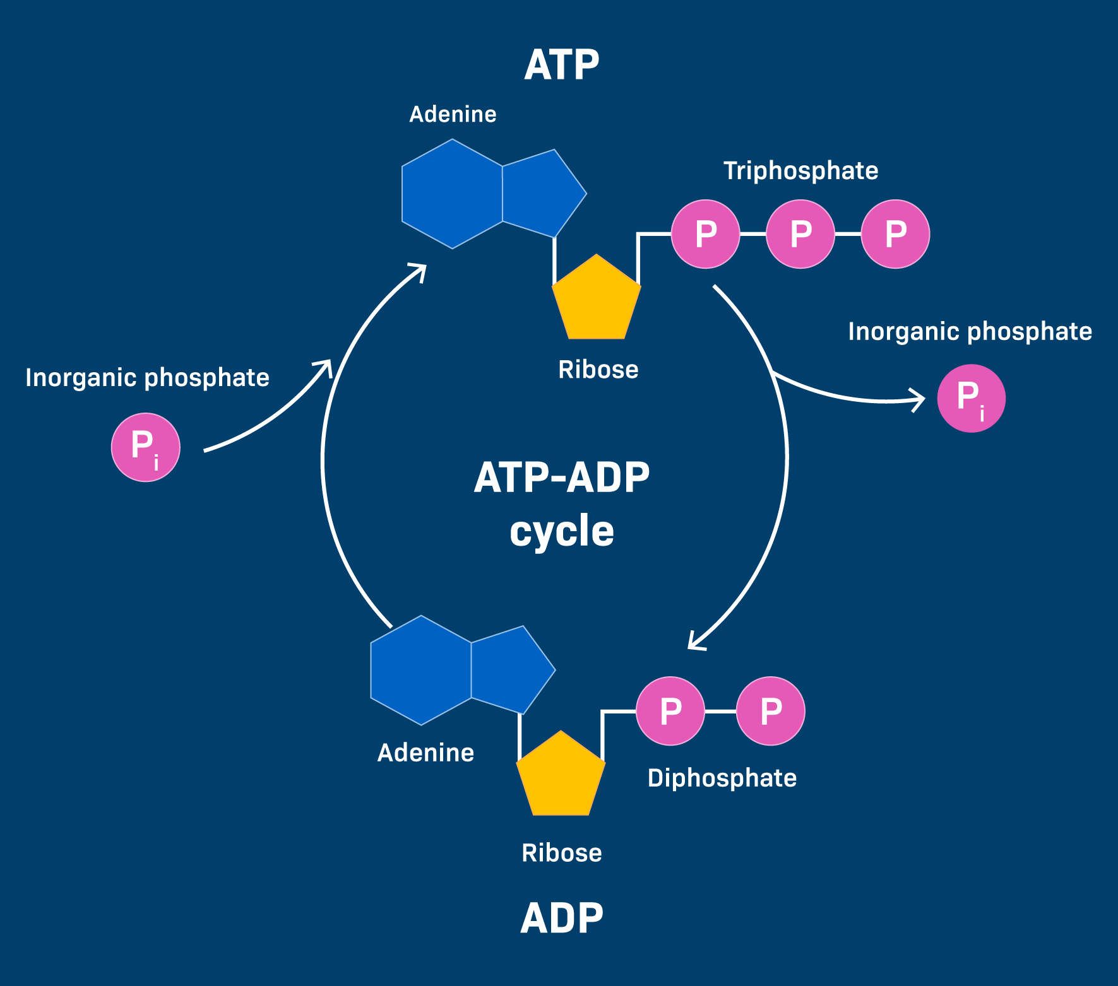

**7.6.2. Structure of ATP Molecule**

The structure of an ATP (adenosine triphosphate) molecule consists of three main components: a nitrogenous base called adenine, a five-carbon sugar called ribose, and a chain of three phosphate groups.

The adenine and ribose form adenosine, which is attached to the first phosphate group, while the second and third phosphate groups are attached to each other in a high-energy chain.

Adenine + Ribose Sugar —> Adenosine  
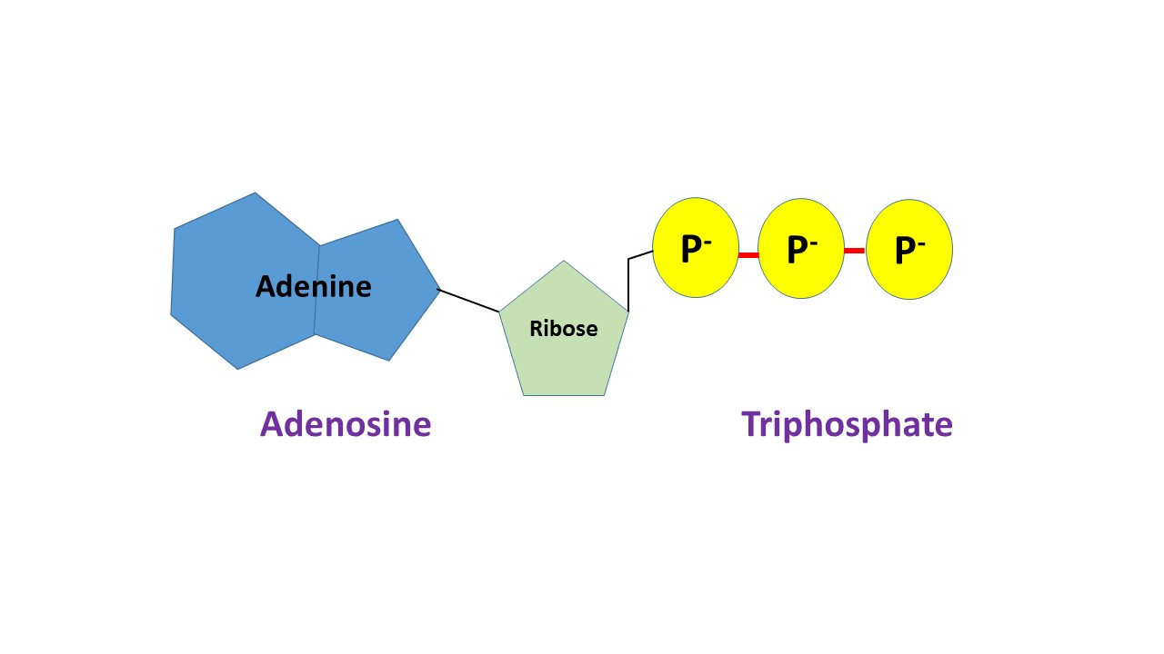

## **7.7 Photosynthesis**

Photosynthesis is the process by which plants make glucose using CO₂, water, and light.

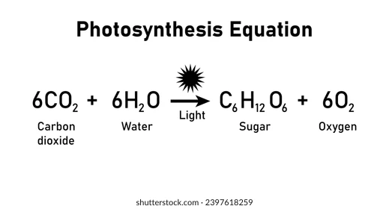

This process captures solar energy, stores it in glucose for the plant, and releases oxygen as a byproduct, forming the basis of most food webs.

**7.7.1. Mechanism of Photosynthesis**

Photosynthesis has two main stages: the light-dependent reactions, which occur in the thylakoid membranes of chloroplasts and use sunlight to split water molecules into oxygen, protons, and electrons, producing ATP and NADPH. In the light-independent reactions (Calvin cycle), which occur in the stroma, the ATP and NADPH are used to convert carbon dioxide into glucose (sugar). Overall, the process uses light energy to transform carbon dioxide and water into glucose and oxygen.

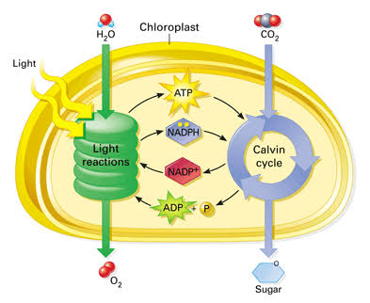

**7.7.1.1. Light Dependent Reactions:**  
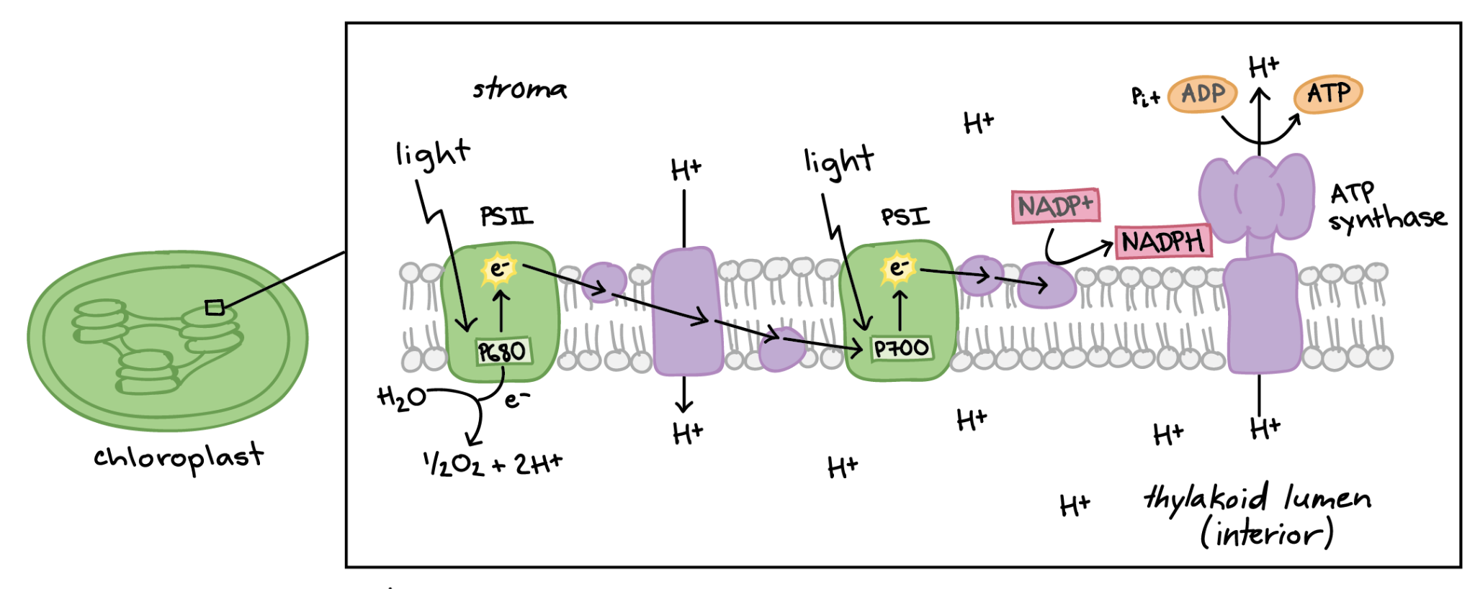

1. Light absorption  
2. Photolysis of water  
3. ATP and NADPH formation

Steps:

1. **Light Absorption (PSII)**: Sunlight strikes chlorophyll in **Photosystem II (PSII)**, exciting electrons to a higher energy level.
2. **Water Splitting (Photolysis)**: To replace lost electrons, water molecules are split (oxidized) in PSII, releasing electrons, protons, and oxygen as a byproduct.
3. **Electron Transport Chain (ETC)**: The high-energy electrons move from PSII down an electron transport chain, releasing energy that pumps protons from the stroma into the thylakoid lumen (interior).
4. **Light Absorption (PSI)**: Electrons reach **Photosystem I (PSI)**, absorb more light energy, and get re-energized.
5. **NADPH Formation**: These energized electrons travel down a second short ETC, eventually reducing 𝑁𝐴𝐷𝑃+ to form **NADPH** (an energy carrier).
6. **ATP Synthesis (Chemiosmosis)**: The high concentration of protons in the thylakoid lumen flows back into the stroma through an enzyme called **ATP synthase**, generating **ATP** (another energy carrier) from ADP and phosphate.

**7.7.1.2. Light Independent Reactions (Calvin Cycle):**

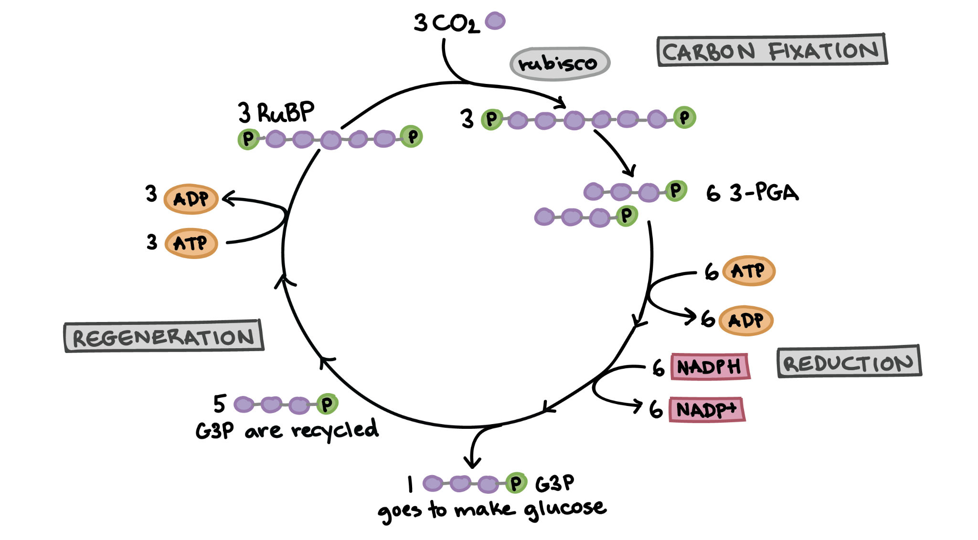

1. CO₂ fixation  
2. Formation of 3-carbon sugars  
3. Glucose formation

Step:

**Carbon Fixation**

* **CO2 Enters:** A molecule of carbon dioxide enters the cycle.
* **Joining RuBP:** The enzyme RuBisCO attaches this carbon dioxide to a five-carbon sugar called Ribulose-1,5-bisphosphate (RuBP).
* **Splitting:** This creates an unstable six-carbon compound that immediately splits into two molecules of a three-carbon compound called 3-phosphoglycerate (3-PGA).
* For every six molecules of G3P produced, one exits the cycle to build glucose, while the other five are used to regenerate RuBP.

**7.7.2. Limiting Factors**

• Light  
• CO₂  
• Temperature

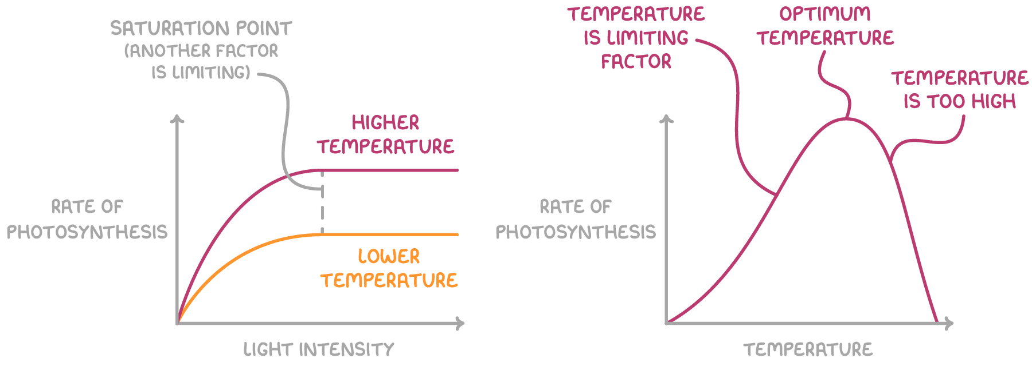

## **7.8 Respiration**

**Respiration releases energy from food.  
  
A. Anaerobic Respiration:**

• Occurs without oxygen  
• Produces alcohol or lactic acid

**Alcoholic Fermentation:** Glucose breaks down into ethanol and carbon dioxide.

Glucose → Ethanol + Carbon Dioxide + Energy (2 ATP)

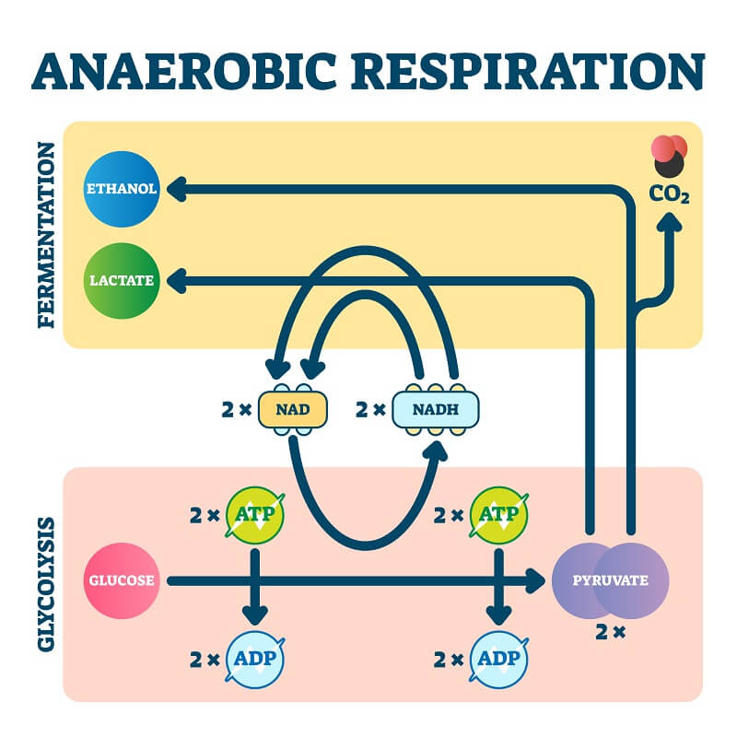

**Lactic Acid Fermentation:** During strenuous exercise, glucose breaks down into lactic acid, regenerating NAD+ to keep glycolysis running.

Glucose → Lactic Acid + Energy (2 ATP)

**7.8.1.1. Importance of Anaerobic Respiration**

* **Energy for strenuous activity:** In the absence of sufficient oxygen, animals and plants can use anaerobic respiration for short bursts of energy.
* **Survival in low-oxygen environments:** Microorganisms, such as bacteria in deep-sea sediments or waterlogged soils, rely on anaerobic respiration to survive in oxygen-deprived habitats.
* **Muscle function:** During intense exercise, muscle cells may switch to anaerobic respiration for quick ATP production. However, this can lead to the buildup of lactic acid, which causes muscle cramps.

**7.8.2. Aerobic Respiration:**

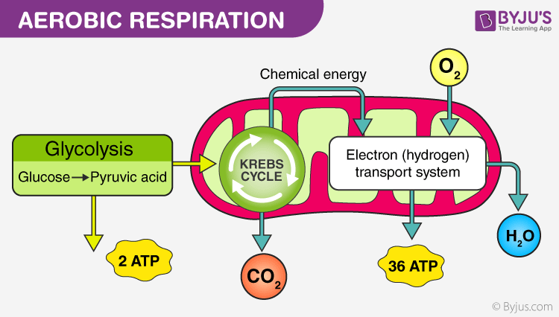

• Occurs with oxygen  
• Produces CO₂, H₂O, and energy

**7.8.3. Mechanism of Aerobic Respiration**

1. **Glycolysis:** One glucose molecule (6-carbon) is split into two molecules of pyruvate (3-carbon).  
2. **Acetyl CoA formation**  
3. **Krebs Cycle:** Pyruvate enters the mitochondria, gets converted to acetyl-CoA, and enters a cycle that fully oxidizes it, releasing CO2.  
4. **Electron Transport Chain:** Electrons from NADH and FADH2 are passed down an Electron Transport Chain, powering proton pumps. Oxygen accepts these electrons, forming water. The proton gradient drives ATP synthase to produce massive amounts of ATP.

**ATP Usage:**

• Muscle movement  
• Brain activity  
• Growth and repair



